How To Attract Your Ideal Clients

With Kat Millar

Remember: You have a zone of genius that others need and don’t have!

The 4 Essential Elements of a Killer Social Media Strategy

BRAND | CONTENT
TRAFFIC | FUNNEL

Notes:

3 Brand Elements

1.

2.

3.

5 Reasons Most Entrepreneurs Struggle To Get Clients

- Not enough ___________________________activities

- No clear ___________________

- Unwilling to do what ______________________aren’t
- A ___________________niche
- Unwilling to ___________________

Choose the one where you have the greatest opportunity to improve.

The 5-Step Client Attraction Formula

1. IDENTIFY: Your Ideal Client

Choose a micro niche, rather than a broad niche
What specific problem will you help a specific person solve?

2. LOCATE: Where They Are Hanging Out?

Where you will consistently add value to your ideal clients?

Online:

1.

2.

Offline:

1.

2.

3. CAPTIVATE: Share Valuable Content

Create and post your own original, valuable content that your ideal client wants.

What kind of content method would you like to create more of?
Captions, Stories, Lives, Blogs, Videos etc

4. OFFER: Create An Irresistible Offer

Examples:

1-On-1 Coaching program, 1-day event, Group Program, Online course, Membership, Retreat

Offer Creation 3-Step Process

1.

2.

3.
5. INVITE: Create a freebie + lead page

Create a valuable freebie that your ideal client wants

Examples:

Cheatsheet, guide, checklist, quiz, video, review, assessment, blueprint

Super-charged Client Attraction Funnel

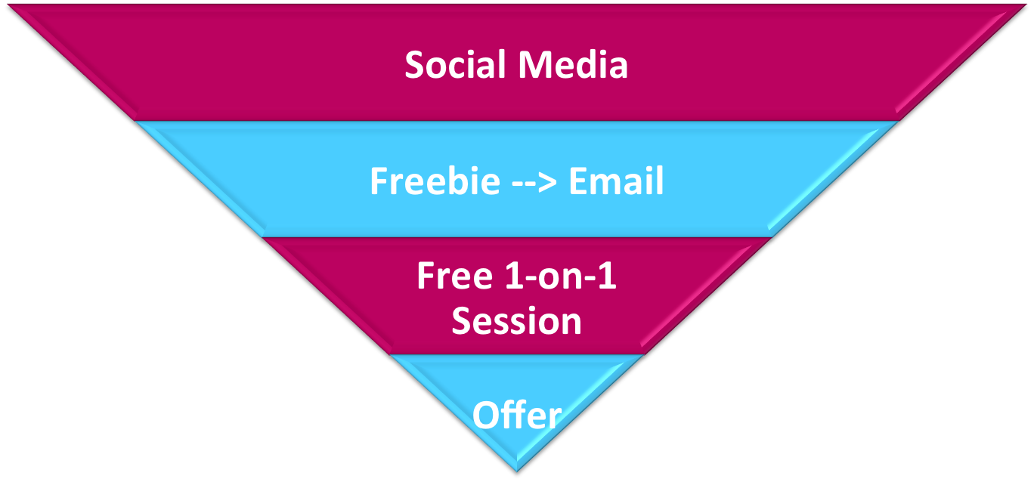

Slow Vs. Supercharged

Slow | Supercharged
Using only your own accounts | Facebook groups
Hashtags | Facebook ads
Reposting / Copying | Collaborations
Only using online marketing | Running events
Relying only on social media | Creating a freebie + funnel

Amplify Your Influence Accelerator:

Starts 10th June: bit.ly/influence-accelerator

